I can read ‘sh’ words.

We went to the shop.

I can see a shark!

The sheep sat on the grass.

We went on a ship. 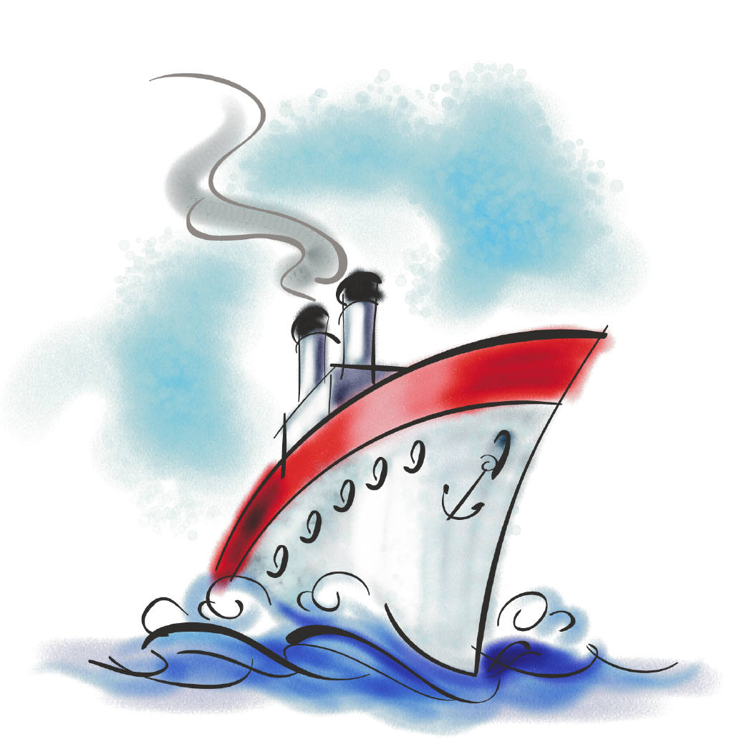

The fish is in the tank.

The man had to push the brush.

The shoes are red.

